**Project 2**

Tittle

**Master Mind (AI Ver)**

Course

**CSC-7**

Section

**42645**

Due Date

**June 9, 2017**

Author

**Sili Guo**

1. **Introduction**

Master Mind is a tradition American game which has a high requirement of logic thinking and basic knowledge for algorithm. During the game, player are asked to guess the color and position of a set of balls that listed in random order. There will be hints for the correct color numbers and correct color and position numbers each turn; and players can use this hint to make further guess.

During each turn, players should use logic and the previous result to eliminate the wrong color and approach the range of correct colors. Sometimes, it is a good strategy to first get all colors correct, then consider about the positions.

Also, when guessing each time, trying to put balls in different position can help you to shorten the steps you need to find out the correct position of each ball.

Players who guess all balls in correct color and correct positions will win the game. Some Master Mind game has a restriction of turn numbers to get correct, others just record the turns players have spent.

**II. Game Rules**

**A. Basic Rules**

1. Start a new game.
2. Choose game mode.
3. Make guesses and look at hints.
4. Check turn numbers you have used to solve the game.

**B. Game Mode**

1. The number of balls.
   * 4 balls
   * 6 balls
   * 8 balls
2. Duplicated
   * Allow duplicated
   * Don’t allow duplicated

**C. Win**

1. Who has all positions correct win the game.
2. )If you want to compete with friends, compare the turn numbers both used to win the game!

**D. AI Version**

1. In the newest update of AI Version, player can pick a random number from 0000~9999, and ask computer to break the code.
2. The AI based on finding the best condition to break the code.

**III. Summary**

|  |  |
| --- | --- |
| **Total Line of Code** | **250** |
| **Comment Line** | - |
| **Variable** | 12 |
| **Function** | 3 |

Basically, this Master Mind game allows player to have choices of how many balls for guessing and if duplicated is allowed. The program is build on the combination of switch case and loop. I used dynamic array to utilize the change between the number of balls. To make the process fluent, I use the windows clear command to refresh the new pages.

In the newest AI Version, I create an AI to break the code that player gives. It is kind of hard to generalize all condition in the game, and is easily to miss some condition. So I searched online and see a basic way to generalize an AI is to find the best solution in each turn. So I initialized a system called score. All the judgement inside the code is based on this system. If the condition is considered as better by computer, it will keep the charges; otherwise, it will come back to original condition, and this helps me a lot to solve this problem.

**IV. Description**

**A. Flowcharts**

Main: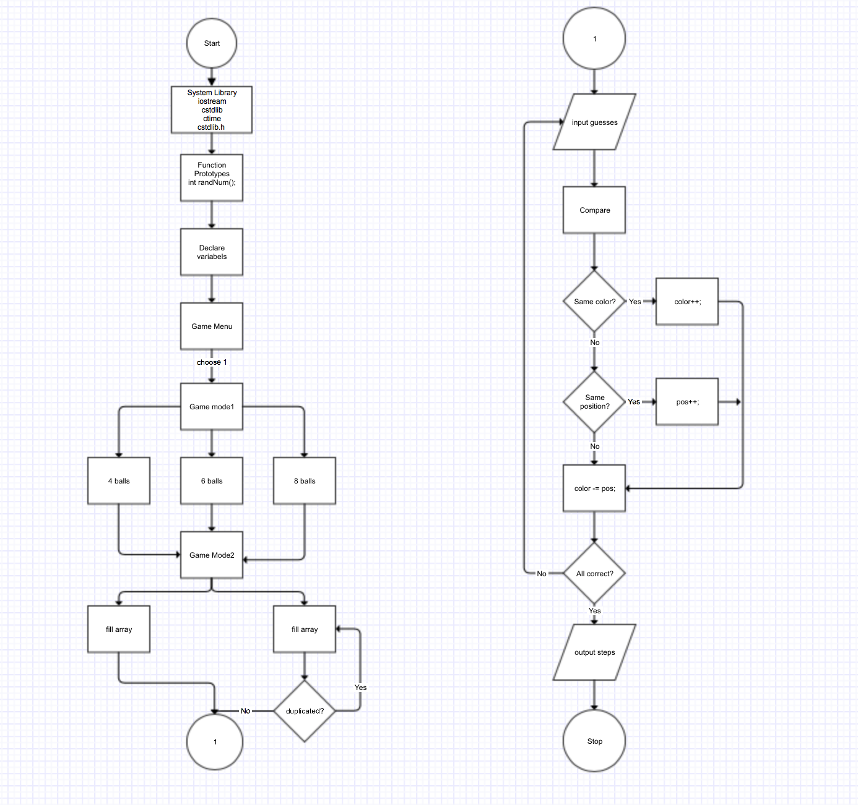

**B. Process**

First, choose game menu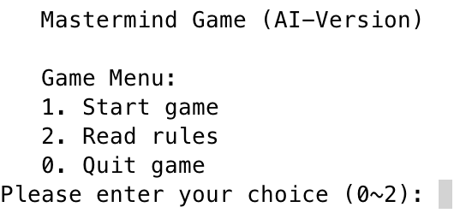

Suggest read game rules before playing game.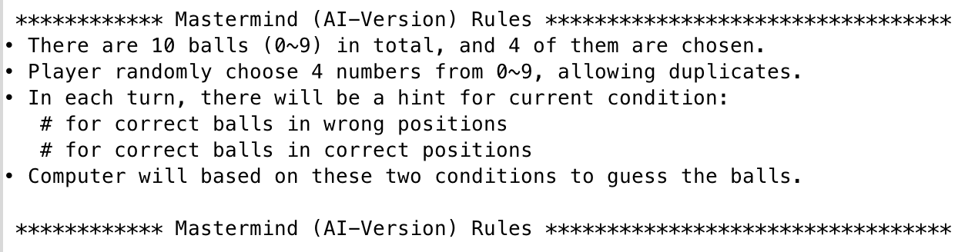

Start game.

Ask User to input 4 numbers (For example, 8 3 8 9).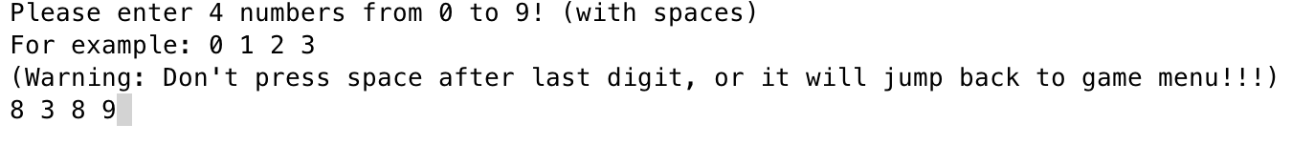

Computer will break the code for you.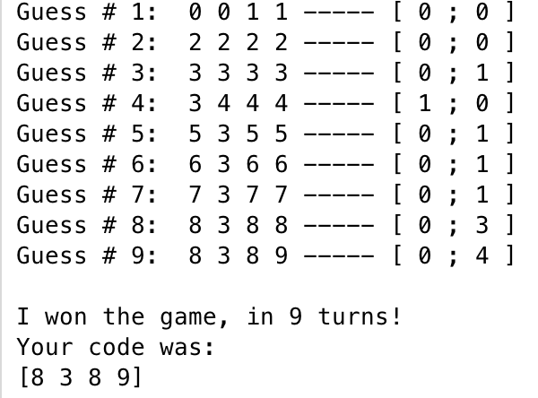

press 0 to quit the gameScreen Shot 2017-04-20 at 3.11.47 AM.png

**VI. Code**

/*

* File: main.cpp

* Author: Sili Guo

* Created on June 4, 2017

* Purpose: Mastermind Game AI

* Comment: The AI judge based on "better condition",

* which means that it changes when find a better condition,

* keep original condition if the new condition is not better.

* The judgment of condition based on the system of "score" I declared.

* There are 13 levels of scores that are used for judgment.

*/

//System Libraries

#include <iostream>

#include <stdlib.h>

using namespace std;

//User Libraries

//Global Constants

//Function Prototypes

void check(int [], int [], int []);

int score(int, int);

void base10counter(int []);

//Execution Begins here!

int main(int argc, char** argv) {

//Random number seed

srand(static_cast<unsigned int> (time(0)));

//Constants

const int TOTAL = 10;

const int SELCT = 4;

//Declare Variables

int input[4]; //Four balls input by user

int guess[4]; //Computer's output guess

int AI_guess[4]; //Computer's guess inside code

int result[2] = {0, 0}; //{correct balls, correct positions}

int previous_answers[10][4]; //Record previous answers

int previous_scores[10]; //Record previous scores

int gameScore; //The score of computer's final guess

int testScore; //The score used to compare with previous score, deciding for better condition

int start; //Game menu choice

int turn; //Game turns

char enter; //Clear screen signal

bool same; //Check duplicates

do {

system("clear");

//Initialize variables each turn

guess[0] = 0;

guess[1] = 0;

guess[2] = 1;

guess[3] = 1;

AI_guess[0] = 0;

AI_guess[1] = 0;

AI_guess[2] = 1;

AI_guess[3] = 1;

turn = 0;

//Output game menu

cout << endl << " Mastermind Game (AI-Version)" << endl << endl;

cout << " Game Menu:" << endl;

cout << " 1. Start game" << endl;

cout << " 2. Read rules" << endl;

cout << " 0. Quit game" << endl;

cout << "Please enter your choice (0~2): ";

cin >> start;

//If choose quitting game

if (start != 1 && start != 2) {

system("clear");

cout << "You quit the game." << endl;

break;

}

switch (start) {

case 1://Start game

system("clear");

//Promote 4 digits from user

cout << "\n Please enter 4 numbers from 0 to 9! (with spaces)" << endl;

cout << " For example: 0 1 2 3" << endl;

cout << " (Warning: Don't press space after last digit, or it will jump back to game menu!!!)" << endl;

do {

cout << " ";

cin >> input[0] >> input[1] >> input[2] >> input[3];

//Check for validation

if (input[0] < 0 || input[0] > 9 || input[1] < 0 || input[1] > 9

|| input[2] < 0 || input[2] > 9 || input[3] < 0 || input[3] > 9) {

cout << " Invalid input! Please enter in correct form! (eg. 0 1 2 3): " << endl;

}

} while (input[0] < 0 || input[0] > 9 || input[1] < 0 || input[1] > 9

|| input[2] < 0 || input[2] > 9 || input[3] < 0 || input[3] > 9);

//Initialize turns to 15

while (turn < 15) {

turn++;

//Output computer's guess

cout << " Guess #";

if (turn < 10) cout << " ";

cout << turn << ": ";

cout << " " << guess[0] << " " << guess[1] << " " << guess[2] << " " << guess[3];

//Check if the guess was correct

check(guess, result, input);

//Calculate game score

gameScore = score(result[0], result[1]);

//Record previous answers and scores

previous_answers[turn - 1][0] = guess[0];

previous_answers[turn - 1][1] = guess[1];

previous_answers[turn - 1][2] = guess[2];

previous_answers[turn - 1][3] = guess[3];

previous_scores[turn - 1] = gameScore;

//If answers is correct, break

if (result[1] == 4)

break;

//Deciding for best condition

bool anySolutions = true;

while (anySolutions) {

//Marking for same condition

bool consistent = true;

//Find a better condition than last time

for (int i = 0; i < turn; i++) {

check(AI_guess, result, previous_answers[i]);

testScore = score(result[0], result[1]);

if (testScore != previous_scores[i]) {

consistent = false;

break;

}

}

//If no better condition, break

if (consistent) break;

base10counter(AI_guess);

//If not win, test if no solution

if (testScore != 13) {

if (AI_guess[0] == 0 && AI_guess[1] == 0 && AI_guess[2] == 1 && AI_guess[3] == 1) {

anySolutions = false;

printf(" ERROR: No solution possible!\n");

}

}

}

//Use the best condition as computer's next guess

guess[0] = AI_guess[0];

guess[1] = AI_guess[1];

guess[2] = AI_guess[2];

guess[3] = AI_guess[3];

//Output result of computer's guess

cout << " ----- [ " << result[0] << " ; " << result[1] << " ]" << endl;

}

//Output last result of computer's guess

cout << " ----- [ " << result[0] << " ; " << result[1] << " ]" << endl;

//If win the game, output result

if (result[1] == 4) {

cout << "\n I won the game, in " << turn << " turns!" << endl;

cout << " Your code was: " << endl;

cout << " [" << guess[0] << " " << guess[1] << " " << guess[2] << " " << guess[3] << "]" << endl;

} else//If did not get solution

cout << "\n Sorry, I did not get the solution!" << endl;

break;

case 2://Read rules

system("clear");

//Output rules and menu

cout << "\n ************ Mastermind (AI-Version) Rules *********************************" << endl;

cout << "• There are 10 balls (0~9) in total, and 4 of them are chosen." << endl;

cout << "• Player randomly choose 4 numbers from 0~9, allowing duplicates." << endl;

cout << "• In each turn, there will be a hint for current condition: " << endl;

cout << " # for correct balls in wrong positions" << endl;

cout << " # for correct balls in correct positions" << endl;

cout << "• Computer will based on these two conditions to guess the balls." << endl;

cout << "\n ************ Mastermind (AI-Version) Rules *********************************" << endl;

break;

default://Quit game

break;

}//End of switch case

cout << "\n Press enter to go back to Game Menu." << endl;

cin.ignore();

do {

enter = getchar();

} while (enter != '\n');

} while (enter == '\n');

//Exit Stage right!

return 0;

}

void check(int guess[], int result[], int input[]) {

//Initialize variables

result[0] = 0;

result[1] = 0;

//copy guess and input for comparing and making changes

int copy1[4] = {0, 0, 0, 0};

int copy2[4] = {0, 0, 0, 0};

//Copy select and guess array to enable for edit

for (int i = 0; i < 4; i++)

copy1[i] = input[i];

for (int i = 0; i < 4; i++)

copy2[i] = guess[i];

//First check correct position

for (int i = 0; i < 4; i++) {

if (copy2[i] == copy1[i]) {

copy1[i] = -1;

copy2[i] = -2;

result[1]++;

}

}

//Then check for correct color

for (int i = 0; i < 4; i++) {

for (int j = 0; j < 4; j++) {

if (j != i) {

if (copy2[i] == copy1[j]) {

result[0]++;

copy1[j] = -1;

break;

}

}

}

}

}

int score(int num, int pos) {

//Initialize scores with different condition

if (num == 0 && pos == 0) return 0;

if (num == 1 && pos == 0) return 1;

if (num == 0 && pos == 1) return 2;

if (num == 2 && pos == 0) return 3;

if (num == 1 && pos == 1) return 4;

if (num == 0 && pos == 2) return 5;

if (num == 3 && pos == 0) return 6;

if (num == 2 && pos == 1) return 7;

if (num == 1 && pos == 2) return 8;

if (num == 0 && pos == 3) return 9;

if (num == 4 && pos == 0) return 10;

if (num == 3 && pos == 1) return 11;

if (num == 2 && pos == 2) return 12;

if (num == 0 && pos == 4) return 13;

}

void base10counter(int num[4]) {

//Count for bounder

num[3]++;

if (num[3] == 10) {

num[2]++;

if (num[2] == 10) {

num[1]++;

if (num[1] == 10) {

num[0]++;

if (num[0] == 10) num[0] = 0;

num[1] = 0;

}

num[2] = 0;

}

num[3] = 0;

}

}